Bidgely’s Non-Smart Meter Disaggregation

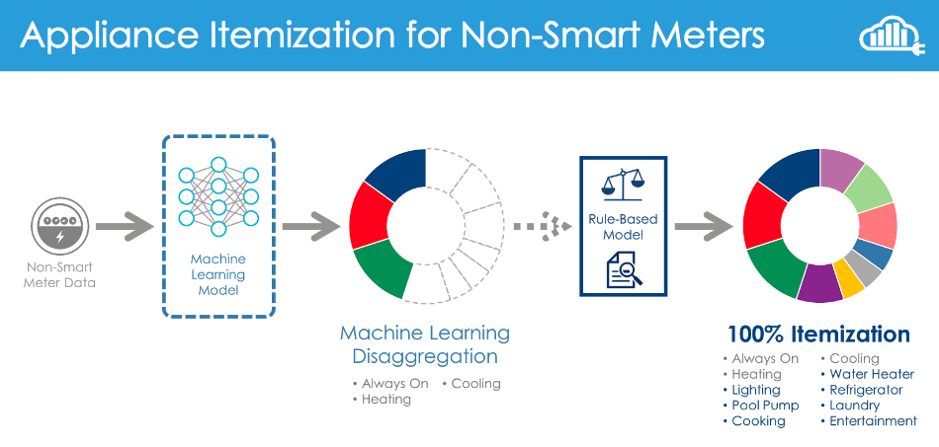

# Background

The model that Bidgely uses to disaggregate non-smart meter (NSM) data is based on a Machine Learning technique called Artificial Neural Networks. Artificial Neural Nets are the same class of Machine Learning models that are being used to develop self-driving cars, image recognition, speech recognition, and many other cutting-edge technologies. What sets these models apart from other Machine Learning techniques is that they are able to quantify the relationship between data and results without depending only on human intuition. The big advantage of this approach is that these models are not constrained by what the human mind can perceive and encode in a model.

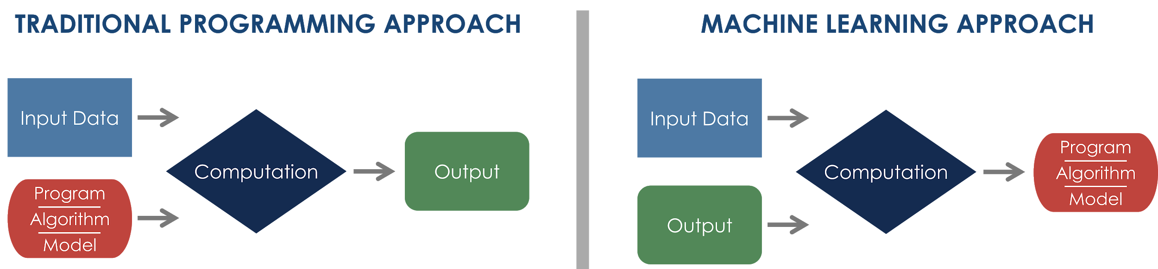

*In the process flow diagram above, the Artificial Neural Network would be contained within the “Computation” box in the Machine Learning approach.*

# NSM Process Overview

**Step 1 | Building the Training Data Set**

As evidenced by the Machine Learning Process Flow diagram above, the Machine Learning Approach requires 2 inputs:

1. Input Data
2. Desired Output (corresponding to the Input Data)

**Step 2 | Training the Model**

Below is an explanation of how this model is employed in determining the itemized consumption for a home in the utility’s customer base.

At a very high level, a Neural Net will create hundreds of transformations of the input data (in this case, monthly consumption values, weather, home and appliance profiles) and create relationships between those transformations, the input data, and the output results. In doing so, the model makes mathematical rules that can observe a set of input data and predict a specific result (in this case, appliance itemization)

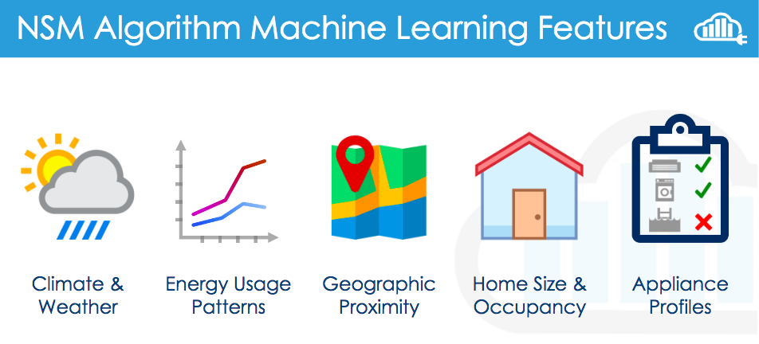

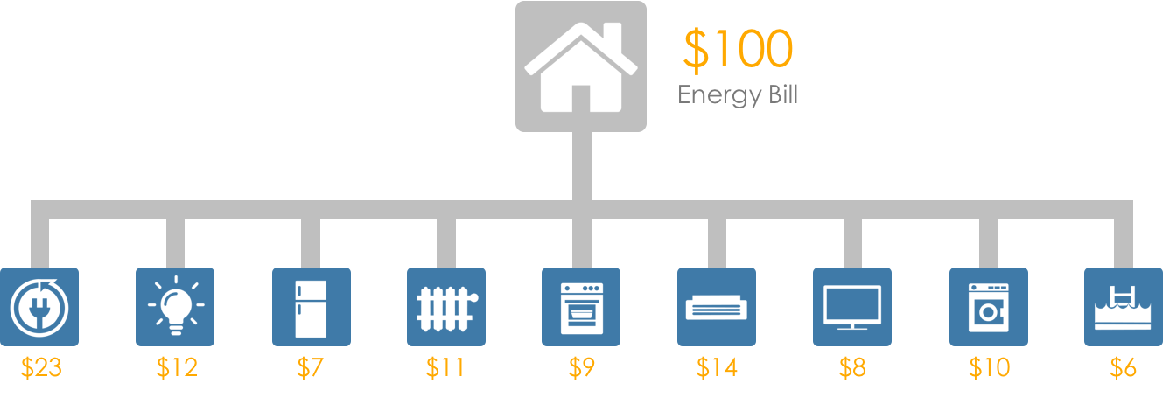

As described above, the Training Data Set described earlier includes both Hawaii homes and Southeast US homes with similar weather conditions. Using this home data, along with the purchased demographic profile data, the Artificial Neural Net will create a model specific to Hawaii load profiles.